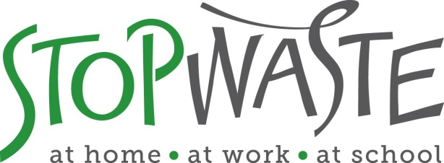

Occupant Training Summary at StopWaste since 2007 move-in
Background: StopWaste holds monthly staff meetings that are required for all staff members. We do not record attendance at these meetings, but typically 90% or more of staff members attend these mandatory meetings.
The following schedule lists staff meetings for which EB or building energy were addressed in the last year, plus a summary of the ongoing trainings available to staff at monthly staff meetings since 2007.
9-11-2013 all staff training
At this staff training, the following topics were covered as part of the EB progress update:
- Performance period process and timeline
- Purchasing criteria
- Waste audit
- Transportation & Occupant Comfort surveys
- Credits we are considering pursuing
7-10-2013 all staff training
At this staff training, the following topics were covered as part of the EB progress update:
- Overview of EB process
- tips on what to do now and through performance period
- update on energy star
- purchasing
- forthcoming occupant surveys
- APPA assessment
- Recruit team members
Between 2009-2013
Semi-annual updates were presented at monthly staff meetings. Topics included comfort issues (hot/cold issues), energy star score update, purchasing criteria, green power partnership overview, Q&A about lights/plugs/appliances, etc.
2007-2008
Training provided as part of the LEED enhanced commissioning training plan immediately following occupation of the renovated building. Logs of attendance were recorded and are included in the LEED commissioning manual from 2007-8.
These trainings included a 1-hour overview for all staff on basic functions of the building’s energy systems. In addition, key staff was trained on advanced energy monitoring (temperature overrides, lighting control panels, BMS, service contract contacts, water systems, etc.).

