Building Name: Night Illumination Levels Report

To use this template: replace red text with information specific to your project.

Measurement Protocol
Light trespass measurements were taken on Date beginning at Time using a [brand and model] light meter. Measurements were taken around the building with no two measurements more than 100 feet apart. Measurements were taken first with the building exterior lights on and then again at each point with the exterior lights off. Interior lights remained at the same level during both sets of measurements. [A piece of masking tape was placed at each measurement location to ensure that both sets of readings were taken in the exact same location.]

Measurement Locations
The map below shows the measurement locations, which are marked with red dots at the property boundary and labeled numerically. The red line marks the property boundary.

[Insert the site plan for your project showing the measurement locations. See below for an example]

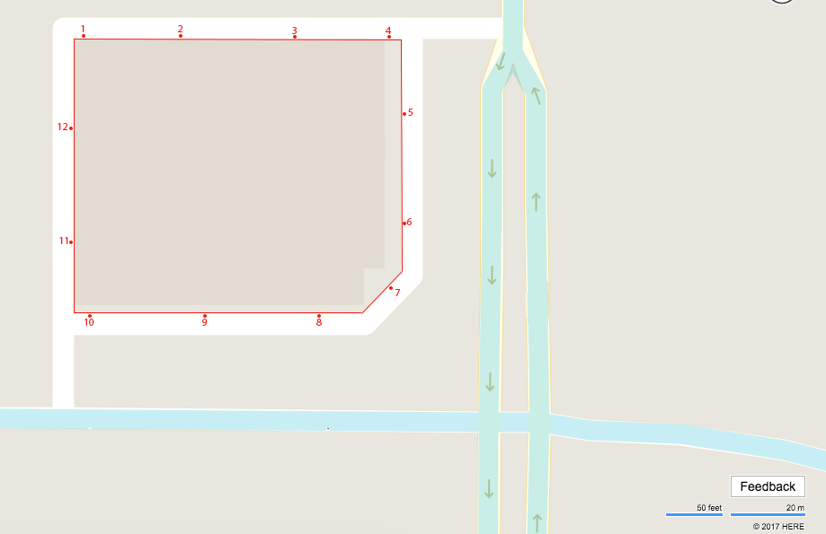

Results
Measurement Point | Exterior Lights On (fc) | Exterior Lights Off (fc) | Percent Change (%)
01 | 1.3 | 1.1 | 15.38
02 | 1.6 | 1.4 | 12.50
03 | 0.9 | 0.8 | 11.11
04 | 0.7 | 0.7 | 0.00
05 | 0.7 | 0.6 | 14.29
06 | 0.7 | 0.6 | 14.29
07 | 1.2 | 1.1 | 8.33
08 | 0.5 | 0.5 | 0.00
09 | 0.9 | 0.8 | 11.11
10 | 1.2 | 1.1 | 8.33
11 | 0.9 | 0.8 | 11.11
12 | 1.3 | 1.2 | 7.69

The illumination level with the exterior lights on was less than 20% above the level measured with the lights off for all measurement locations.

