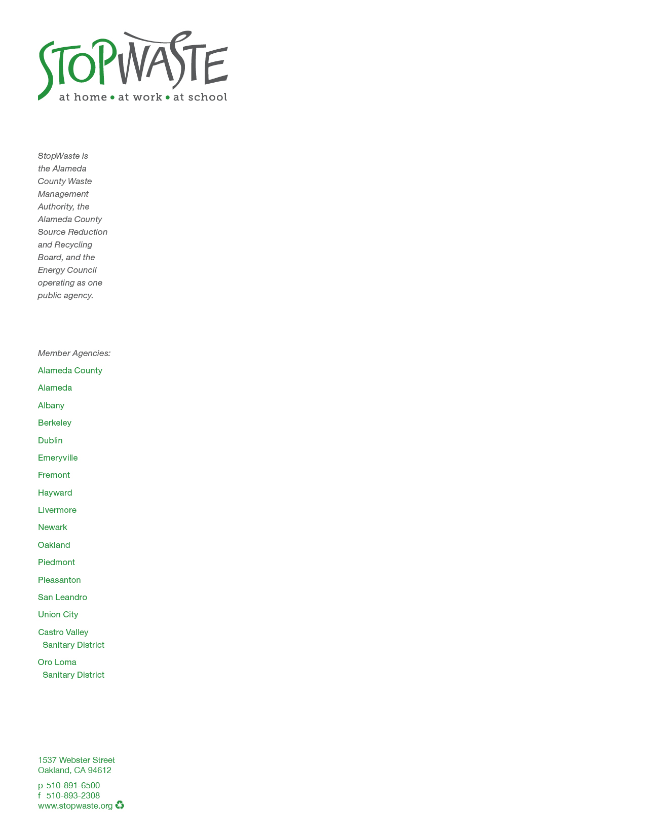
October, 2013

RE: Narrative for EBv4 credit SSc5: Site Management

To Whom It May Concern,

The following narrative describes the type of services we use to manage our building site.

- Landscaped areas: Since our site is quite small (___ square feet), and it is Bay-Friendly Rated, we employ best management practices in sustainable landscape maintenance on 100% of the landcaped area, 100% of the time. These include:
  - No pesticides are used, ever;
  - No power equipment is used for maintenance, ever;
  - No plant debris leaves the site, ever (it is composted on-site and returned to the soil as an amendment. Furthermore, all green waste is banned from landfilling in Alameda County);
  - No synthetic fertilizers are used, ever;
  - No turf has been planted, ever;
  - No stormwater leaves our landscape areas as runoff, ever;
  - Native plants dominate our plant palette;
  - Our irrigation system is fed by rainwater and is monitored regularly with a weather-based irrigation controller;
  - We store and protect all maintenance supplies in a covered shed onsite that was built of salvaged materials.
- Building Exterior Management: Other than infrequent graffiti removal, we do not engage in regular site management activities. Our building has a zero lot line on 3 sides, and the maintenance of those adjacent areas are not under our control. Only the exterior shell and backyard landscape are under our purview.

Sincerely

Wes Sullens

Green Building Program Manager

